Predictive Modeling Using Machine Learning
Binary Classification of Breast Tumor Diagnosis
Task 2 — Final Report
Due Date: 15 July 2026

1. Objective
This project applies supervised machine learning to build and evaluate models that predict outcomes from data. Specifically, the goal was to (1) apply classification algorithms including Logistic Regression, a Decision Tree, and a Random Forest; (2) train and test each model to measure predictive accuracy; and (3) visualize performance using confusion matrices and ROC curves.

2. Dataset
Since no dataset was supplied with the task brief, the Breast Cancer Wisconsin (Diagnostic) dataset was used. It is a well-established benchmark for binary classification and is well suited to demonstrating confusion matrices and ROC-curve analysis.
- Samples: 569 patients
- Features: 30 numeric measurements computed from digitized images of breast mass cell nuclei (e.g., radius, texture, perimeter, area, smoothness)
- Target classes: Malignant (212 cases) and Benign (357 cases)
- Split: 80% training (455 samples) / 20% testing (114 samples), stratified to preserve class balance

3. Methodology

3.1 Preprocessing
Features were standardized (zero mean, unit variance) for Logistic Regression, which is sensitive to feature scale. Tree-based models (Decision Tree, Random Forest) were trained on the raw feature values, since they are scale-invariant.

3.2 Algorithms Applied
- Logistic Regression — a linear model estimating the probability of malignancy vs. benignity; used as an interpretable baseline.
- Decision Tree — a single tree (max depth = 4) that splits on feature thresholds; easy to interpret but prone to overfitting.
- Random Forest — an ensemble of 300 decision trees (max depth = 6) that averages predictions to reduce variance and improve generalization.

3.3 Evaluation Metrics
Each model was evaluated on the held-out test set using Accuracy, Precision, Recall, F1-Score, and ROC-AUC, along with confusion matrices and ROC curves for visual performance comparison.

4. Results

4.1 Performance Summary
Model | Accuracy | Precision | Recall | F1-Score | ROC-AUC
Logistic Regression | 98.2% | 98.6% | 98.6% | 98.6% | 0.995
Random Forest | 94.7% | 95.8% | 95.8% | 95.8% | 0.994
Decision Tree | 93.9% | 95.8% | 94.4% | 95.1% | 0.934

Logistic Regression achieved the strongest overall performance (98.2% accuracy, 0.995 ROC-AUC), narrowly outperforming Random Forest (94.7% accuracy, 0.994 ROC-AUC) and the single Decision Tree (93.9% accuracy, 0.934 ROC-AUC). This is a common pattern on datasets like this one, where classes are close to linearly separable in feature space — a simpler linear model can match or beat more complex ensembles while remaining easier to interpret.
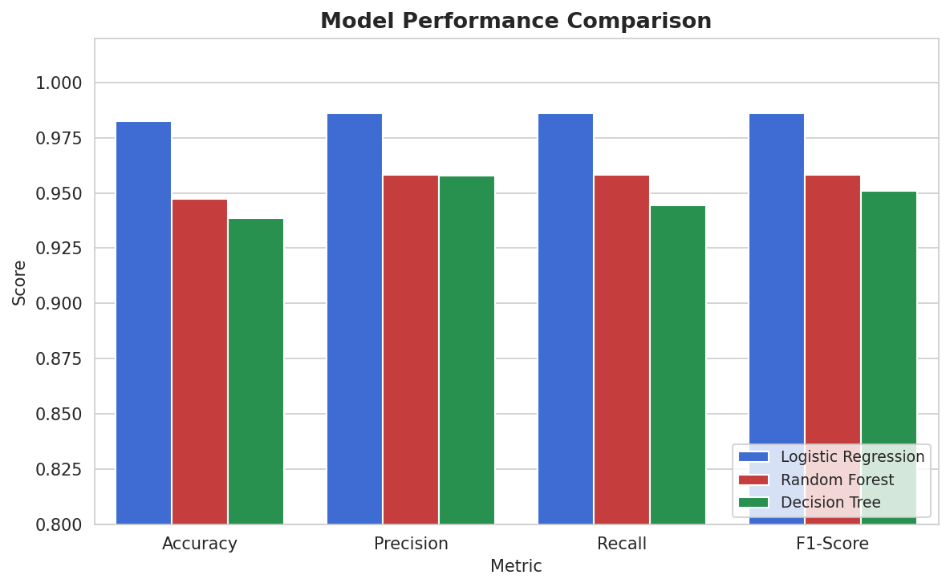
Figure 1. Accuracy, Precision, Recall, and F1-Score across all three models.

4.2 Confusion Matrices
Confusion matrices show how each model's predictions break down against the true labels on the test set (rows = actual class, columns = predicted class).
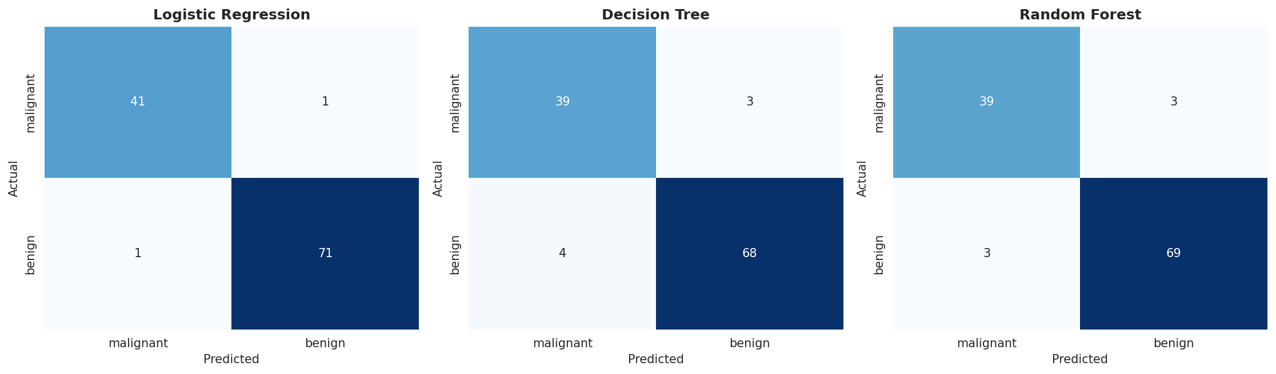
Figure 2. Confusion matrices for Logistic Regression, Decision Tree, and Random Forest.
Logistic Regression made only 2 misclassifications out of 114 test cases. The Decision Tree and Random Forest each made more errors, primarily false negatives (malignant cases predicted as benign) — the costlier type of error in a clinical screening context.

4.3 ROC Curve Comparison
The ROC curve plots the True Positive Rate against the False Positive Rate at varying classification thresholds; the Area Under the Curve (AUC) summarizes overall discriminative ability, with 1.0 being a perfect classifier and 0.5 equivalent to random guessing.
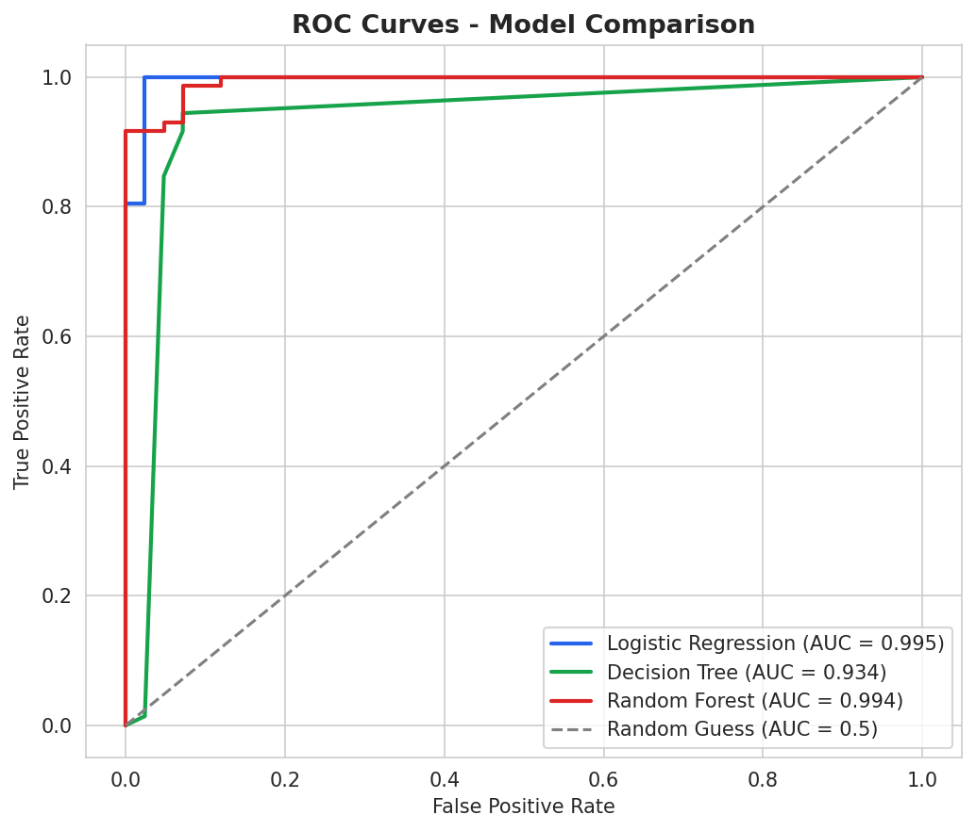
Figure 3. ROC curves for all three models, with AUC scores.
All three models achieved AUC scores above 0.93, indicating strong separability between malignant and benign cases. Logistic Regression's curve hugs closest to the top-left corner, confirming its top-ranked AUC of 0.995.

4.4 Feature Importance
Using the Random Forest's built-in importance scores highlights which measurements most influenced predictions, offering insight into the clinical signal the models are drawing on.
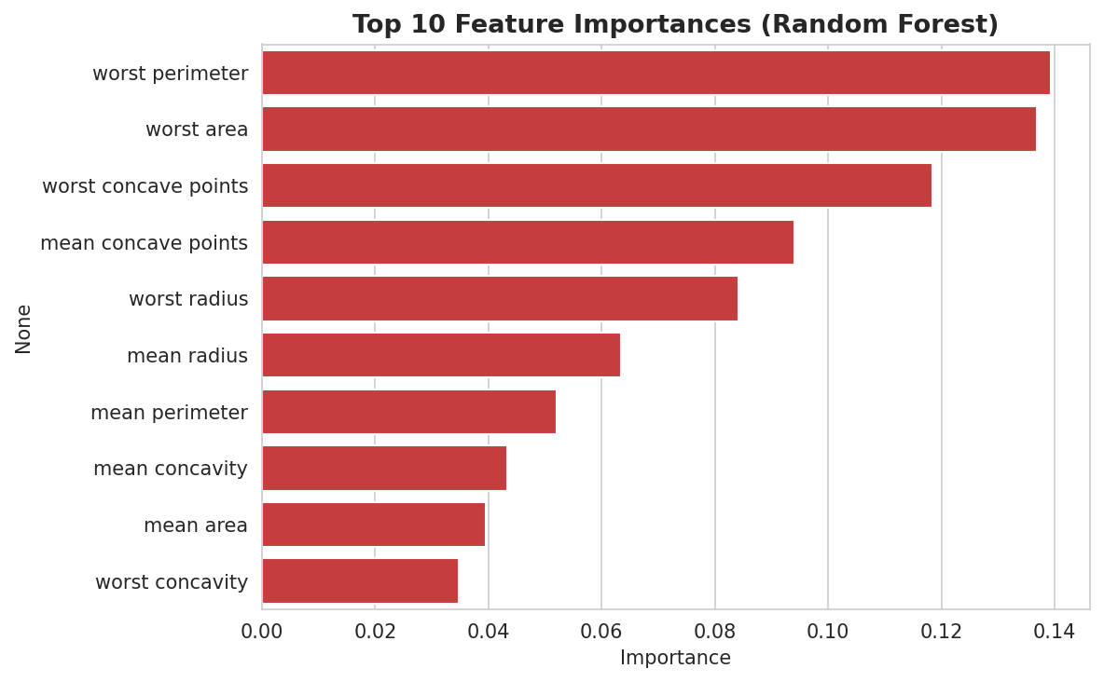
Figure 4. Top 10 most influential features (Random Forest).
Features related to cell nucleus concavity, area, and radius (particularly their 'worst', i.e. largest observed, values) were the strongest predictors of malignancy — consistent with the clinical understanding that larger, more irregularly shaped nuclei are associated with malignant tumors.

5. Discussion
- Best overall model: Logistic Regression, on both accuracy and ROC-AUC, while also being the most interpretable and computationally cheapest to train.
- Random Forest was a close second and would likely be more robust than Logistic Regression on noisier, non-linear, or higher-dimensional real-world data, since ensembling reduces variance.
- The single Decision Tree underperformed both other models, illustrating why ensembling (Random Forest) or regularized linear models are generally preferred over a lone tree for production use.
- False negatives (missed malignant cases) are the most clinically significant error type; in a real deployment, the classification threshold could be tuned to favor recall over precision to reduce them further.

6. Conclusion / Expected Outcome
This project met the task's objectives: three supervised learning algorithms were applied, trained, and tested, and their performance was visualized using confusion matrices and ROC curves. The exercise reinforced core supervised learning concepts including train/test splitting, feature scaling, model comparison, and the trade-offs between interpretability and predictive power across linear models, single trees, and ensembles.

7. Appendix: Environment & Reproducibility
- Language / libraries: Python, scikit-learn 1.8, pandas, matplotlib, seaborn
- Random seed: 42 (used for train/test split and all model initializations, for reproducibility)
- Train/test split: 80/20, stratified by class

